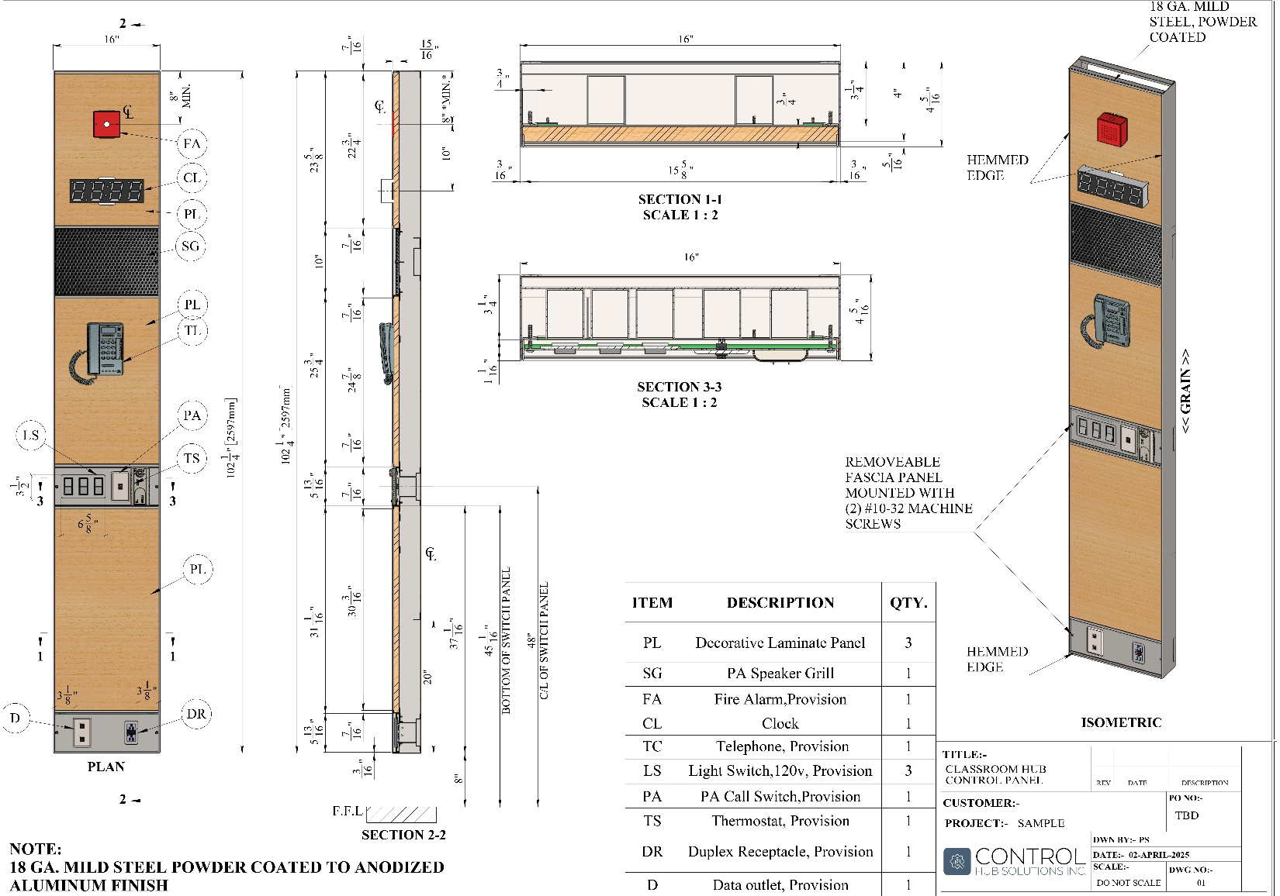
SCHOOL SUBMITTAL PACKAGE FORM
Project
Prepared by
Date
Quote #
PO #
ENCLOSED
Submittal | ☐ | Re-submittal | ☐ | Rev. #

CONTACT INFORMATION
NAME | TITLE | PHONE

SUBMITTAL PACKAGE INSTRUCTIONS
TO ENSURE THAT THE PRODUCTION OF YOUR PROJECT REMAINS ON SCHEDULE, IT IS VITAL THAT YOU COMPLETE THE INFORMATION CORRECTLY. (PLEASE READ THE INSTRUCTIONS BELOW CAREFULLY.)
- Carefully examine all requirements for your panel needs on a room by room basis.

- Complete all forms in detail including device requirements, PLAM selections, requested delivery dates, etc.

- Provide a room number for which you would like you mock up panel to be based on. NOTE: This panel will be used towards your total quantity but will allow for minor modifications.

- Return your completed forms to info@controlhubsolutions.com

NOTE

PLEASE NOTE THAT YOUR PANELS WILL BE MANUFACTURED PER THE FORMS 1 & 2 THAT WE RECEIVE AND THAT WILL BE THE BASIS OF MANUFACTURING AND WILL TAKE PRECEDENCE OVER DRAWINGS AND OTHER PROJECT SPECIFICATIONS SO PLEASE BE SURE ALL FORMS ARE ACCURATELY COMPLETED.

SHIPPING REQUIREMENTS FORM
MANDATORY REQUIREMENTS TO PLACE ORDER
PROJECT NAME | TODAY’S DATE

  REQUESTED DELIVERY DATE
  APPROVED BY
  SHIP TO ADDRESS
  UNIT #
  CITY | PROVINCE | POSTAL CODE

RECEIVING INFORMATION
Site Contact
Contact Phone

Type of freight required | ☐ | LTL | ☐ | Direct | ☐ | PU truck
 | ☐ | Other
Off-Loading equipment on site |  |  | ☐ | Fork lift | ☐ | Pallet jack
 | ☐ | Other

APPROVED BY (PRINT NAME AND POSITION) | DATE

FORM – 1 PANEL DETAILS
PLASTIC LAMINATE COLOURS
Please select 2 colours (an alternate in case your first selection has been discontinued). Colours selected are from a standard colour range:
FORMICA | PIONITE | ARBORITE | WILSONART
www.formica.com | www.pionite.com | www.arborite.com | www.wilsonart.com

Primary Selection
 | COLOUR | MANUFACTURER
Secondary Selection
 | COLOUR | MANUFACTURER

DEVICE DETAILS REQUIRED
  LIGHT SWITCHES
  ☐ | 120 v | ☐ | 347 v | ☐ | toggle
  ☐ | decora | ☐ | other
  DULPEXES
  ☐ | regular | ☐ | Decora style
  ☐ | other
  THERMOSTAT
  ☐ | 7/8 hole | ☐ | 1104 box
  PA CALL SWITCH
  ☐ | 1 3/8” x 13/16 punch out | ☐ | 1104 box
  FIRE ALARM
  ☐ | 1104 box
  ☐ | other
  CLOCK
  ☐ | Flush mount battery |  | ☐ | 1104 box
  ☐ | other
  VOICE DATA
  ☐ | blank |  | ☐ | 1104 box
  ☐ | other
  OTHER DEVICES
APPROVED BY (PRINT NAME AND POSITION) | SIGNATURE | DATE

FORM – 2 INDIVIDUAL ROOM SCHEDULE
PRINT AS MANY INDIVIDUAL ROOM SCHEDULES AS REQUIRED
ROOM SCHEDULE

  Room Number
  Ceiling height (mm)
  Panel height (mm)
  # of switches
  Left or Right switches
  Duplexes
  Voice/Data
  T-Stat
  PA Call Switch
  Fire Alarm
  Clock
  Other:
  Room Number
  Ceiling height (mm)
  Panel height (mm)
  # of switches
  Left or Right switches
  Duplexes
  Voice/Data
  T-Stat
  PA Call Switch
  Fire Alarm
  Clock
  Other:
  Room Number
  Ceiling height (mm)
  Panel height (mm)
  # of switches
  Left or Right switches
  Duplexes
  Voice/Data
  T-Stat
  PA Call Switch
  Fire Alarm
  Clock
  Other:
  Room Number
  Ceiling height (mm)
  Panel height (mm)
  # of switches
  Left or Right switches
  Duplexes
  Voice/Data
  T-Stat
  PA Call Switch
  Fire Alarm
  Clock
  Other:
  Room Number
  Ceiling height (mm)
  Panel height (mm)
  # of switches
  Left or Right switches
  Duplexes
  Voice/Data
  T-Stat
  PA Call Switch
  Fire Alarm
  Clock
  Other:
  Room Number
  Ceiling height (mm)
  Panel height (mm)
  # of switches
  Left or Right switches
  Duplexes
  Voice/Data
  T-Stat
  PA Call Switch
  Fire Alarm
  Clock
  Other:

Total Quantity of Units for Page

FORM – 2 INDIVIDUAL ROOM SCHEDULE
PRINT AS MANY INDIVIDUAL ROOM SCHEDULES AS REQUIRED
ROOM SCHEDULE

  Room Number
  Ceiling height (mm)
  Panel height (mm)
  # of switches
  Left or Right switches
  Duplexes
  Voice/Data
  T-Stat
  PA Call Switch
  Fire Alarm
  Clock
  Other:
  Room Number
  Ceiling height (mm)
  Panel height (mm)
  # of switches
  Left or Right switches
  Duplexes
  Voice/Data
  T-Stat
  PA Call Switch
  Fire Alarm
  Clock
  Other:
  Room Number
  Ceiling height (mm)
  Panel height (mm)
  # of switches
  Left or Right switches
  Duplexes
  Voice/Data
  T-Stat
  PA Call Switch
  Fire Alarm
  Clock
  Other:
  Room Number
  Ceiling height (mm)
  Panel height (mm)
  # of switches
  Left or Right switches
  Duplexes
  Voice/Data
  T-Stat
  PA Call Switch
  Fire Alarm
  Clock
  Other:
  Room Number
  Ceiling height (mm)
  Panel height (mm)
  # of switches
  Left or Right switches
  Duplexes
  Voice/Data
  T-Stat
  PA Call Switch
  Fire Alarm
  Clock
  Other:
  Room Number
  Ceiling height (mm)
  Panel height (mm)
  # of switches
  Left or Right switches
  Duplexes
  Voice/Data
  T-Stat
  PA Call Switch
  Fire Alarm
  Clock
  Other:

Total Quantity of Units for Page

FORM – 2 INDIVIDUAL ROOM SCHEDULE
PRINT AS MANY INDIVIDUAL ROOM SCHEDULES AS REQUIRED
ROOM SCHEDULE

  Room Number
  Ceiling height (mm)
  Panel height (mm)
  # of switches
  Left or Right switches
  Duplexes
  Voice/Data
  T-Stat
  PA Call Switch
  Fire Alarm
  Clock
  Other:
  Room Number
  Ceiling height (mm)
  Panel height (mm)
  # of switches
  Left or Right switches
  Duplexes
  Voice/Data
  T-Stat
  PA Call Switch
  Fire Alarm
  Clock
  Other:
  Room Number
  Ceiling height (mm)
  Panel height (mm)
  # of switches
  Left or Right switches
  Duplexes
  Voice/Data
  T-Stat
  PA Call Switch
  Fire Alarm
  Clock
  Other:
  Room Number
  Ceiling height (mm)
  Panel height (mm)
  # of switches
  Left or Right switches
  Duplexes
  Voice/Data
  T-Stat
  PA Call Switch
  Fire Alarm
  Clock
  Other:
  Room Number
  Ceiling height (mm)
  Panel height (mm)
  # of switches
  Left or Right switches
  Duplexes
  Voice/Data
  T-Stat
  PA Call Switch
  Fire Alarm
  Clock
  Other:
  Room Number
  Ceiling height (mm)
  Panel height (mm)
  # of switches
  Left or Right switches
  Duplexes
  Voice/Data
  T-Stat
  PA Call Switch
  Fire Alarm
  Clock
  Other:

Total Quantity of Units for Page

FORM – 2 INDIVIDUAL ROOM SCHEDULE
PRINT AS MANY INDIVIDUAL ROOM SCHEDULES AS REQUIRED
ROOM SCHEDULE

  Room Number
  Ceiling height (mm)
  Panel height (mm)
  # of switches
  Left or Right switches
  Duplexes
  Voice/Data
  T-Stat
  PA Call Switch
  Fire Alarm
  Clock
  Other:
  Room Number
  Ceiling height (mm)
  Panel height (mm)
  # of switches
  Left or Right switches
  Duplexes
  Voice/Data
  T-Stat
  PA Call Switch
  Fire Alarm
  Clock
  Other:
  Room Number
  Ceiling height (mm)
  Panel height (mm)
  # of switches
  Left or Right switches
  Duplexes
  Voice/Data
  T-Stat
  PA Call Switch
  Fire Alarm
  Clock
  Other:
  Room Number
  Ceiling height (mm)
  Panel height (mm)
  # of switches
  Left or Right switches
  Duplexes
  Voice/Data
  T-Stat
  PA Call Switch
  Fire Alarm
  Clock
  Other:
  Room Number
  Ceiling height (mm)
  Panel height (mm)
  # of switches
  Left or Right switches
  Duplexes
  Voice/Data
  T-Stat
  PA Call Switch
  Fire Alarm
  Clock
  Other:
  Room Number
  Ceiling height (mm)
  Panel height (mm)
  # of switches
  Left or Right switches
  Duplexes
  Voice/Data
  T-Stat
  PA Call Switch
  Fire Alarm
  Clock
  Other:

Total Quantity of Units for Page

FORM – 2 INDIVIDUAL ROOM SCHEDULE
PRINT AS MANY INDIVIDUAL ROOM SCHEDULES AS REQUIRED
ROOM SCHEDULE

  Room Number
  Ceiling height (mm)
  Panel height (mm)
  # of switches
  Left or Right switches
  Duplexes
  Voice/Data
  T-Stat
  PA Call Switch
  Fire Alarm
  Clock
  Other:
  Room Number
  Ceiling height (mm)
  Panel height (mm)
  # of switches
  Left or Right switches
  Duplexes
  Voice/Data
  T-Stat
  PA Call Switch
  Fire Alarm
  Clock
  Other:
  Room Number
  Ceiling height (mm)
  Panel height (mm)
  # of switches
  Left or Right switches
  Duplexes
  Voice/Data
  T-Stat
  PA Call Switch
  Fire Alarm
  Clock
  Other:
  Room Number
  Ceiling height (mm)
  Panel height (mm)
  # of switches
  Left or Right switches
  Duplexes
  Voice/Data
  T-Stat
  PA Call Switch
  Fire Alarm
  Clock
  Other:
  Room Number
  Ceiling height (mm)
  Panel height (mm)
  # of switches
  Left or Right switches
  Duplexes
  Voice/Data
  T-Stat
  PA Call Switch
  Fire Alarm
  Clock
  Other:
  Room Number
  Ceiling height (mm)
  Panel height (mm)
  # of switches
  Left or Right switches
  Duplexes
  Voice/Data
  T-Stat
  PA Call Switch
  Fire Alarm
  Clock
  Other:

Total Quantity of Units for Page
GRAND TOTAL QUANTITY UNITS REQUIRED

